# 

# The Utah Association of Healthcare Quality Presents its

# Annual Education Conference



# Quality: Breaking Down Barriers in Healthcare

## Friday, October 4, 2019

2nd Floor Women’s Pavilion

Lamb Auditorium

HCA St. Mark’s Hospital

1200 E. 3900 S., Salt Lake City, UT 84124

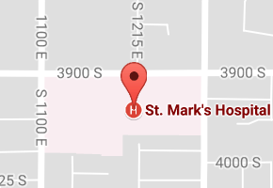

### Registration

### Register and pay securely online at <http://www.uahq.org/Annual-Conference.html> or complete this form and return with your payment to:

UAHQ

Attn: Conference Registration

### P.O. Box 521073

Salt Lake City, UT 84152

Name: _________________________________________

Position/Title:___________________________________

Organization: ___________________________________

Preferred mailing address: Home  Work 

Street Address: _________________________________

City_____________________________________________

State___________________ Zip Code_______________

Preferred E-Mail address: Home  Work 

________________________________________________

Preferred Telephone #: Home  Work 

(_____) - ______ - ____________

### Registration Fees

|  |  |
| --- | --- |
| UAHQ Member | $60.00 |
| Register and Join/Renew | $85.00 |
| Non-member | $105.00 |

**Check here if you intend to pay at the door.**

### Conference Agenda

|  |  |  |
| --- | --- | --- |
| 7:30 | Registration & Continental Breakfast |  |
| 8:00 | Welcome | Heather Bloomfield |
| 8:15 | Breaking down barriers with innovation throughout the healthcare landscape | Marc Bennett |
| 9:15 | Most common regulatory findings for infection prevention | Cherie Frame |
| 10:15 | Break |  |
| 10:30 | Engaging medical staff in quality metrics | Dr. Costanzo |
| 11:30 | Implementing integrated mental health into the primary care setting | Mike Hancock |
| 12:30 | Networking Lunch, Business Meeting, Poster Exhibit, Nominations Drawing! Must be present to win | Heather Bloomfield |
| 1:15 | Break free of clutter & disorganization: your ultimate office awaits | Marla Dee |
| 2:15 | Quality transformation within Boeing: improved processes equal better outcomes | Chad Oishi |
| 3:15 | Break |  |
| 3:30 | Creating safety in your dialogue | Henry Killacky |
| 4:30 | Drawing! Must be present to win | Linda Egbert |
| 4:45 | Wrap Up and Evaluations | Heather Bloomfield |

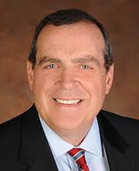**Marc Bennett**, **MA** is president and chief executive officer at Comagine Health (formerly HealthInsight and Qualis Health) a private, nonprofit organization dedicated to improving health and health care. *He**also*serves as chair of the board of directors for the Network for Regional Health Improvement (NRHI),American Health Quality Association (AHQA), past president, board member, and National Quality Forum (NQF) Eisenberg Award Committee, member (2014-present).

**Cherie Frame,** **MSN, RN, CIC** obtained her BSN from Brigham Young University and completed her MSN degree from Western Governors University. She obtained her National Certification in Infection Control and is a member of APIC- Association for Professionals in Infection Control and Epidemiology National Organization. She has served as local Chapter President for APIC as well is currently on the Board of Directors.

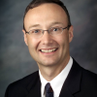**Ralph Costanzo, MD, MHA** is currently the Chief Medical Officer at HCA St. Mark’s Hospital. Previously, he practiced as a board-certified orthopedic hand surgeon in the Hand and Upper Extremity Center of Excellence at Ortho Montana, PSC, in Billings, Montana and completed an MHA at the Carlson School of Management at the University of Minnesota in 2016. Currently, he greatly enjoys his work in the areas of provider engagement, hospital quality and process improvement, and alignment around value-based care initiatives.

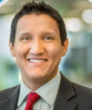**Mike Hancock, MHA** serves as Assistant Regional Operations Officer of the North Salt Lake Geography of Intermountain Medical Group at Intermountain Healthcare. Mike is responsible for Medical Group operations in the northern area of the Salt Lake Valley, including primary care, behavioral health, OBGYN, surgical services, among others. Mike earned both Master of Health Administration and undergraduate Health Administration degrees from Weber State University.

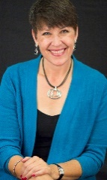**Marla Dee** is the creator of the Clear & SIMPLE Systems®. She has been a powerful trainer to numerous organizations, audiences and organizers for 19 years. Marla has spoken for audiences around the world and is known for inspiring and empowering people. Marla is the author of Get Organized, the Clear & SIMPLE Way, The ART of Letting Go, The Simple Life, and all three levels of The Professional Organizer Training Program.

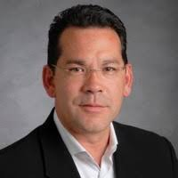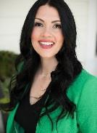**Chad Oishi** has been with the Boeing Company for 31 years. He has also led large scale implementation of Lean Manufacturing, Employee Engagement and Line Side Support Cells. He currently leads the Quality organization for Boeing’s three Salt Lake City facilities.

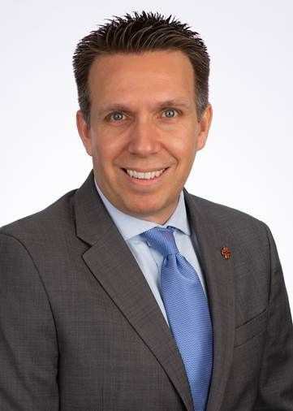**Henry Killacky, PHR** is the director of leadership and organizational development throughout HCA Healthcare’s Mountain Division.  Henry has 15 years of organizational development experience and has spent the past nine years in the healthcare industry.  He earned a professional in human resources (PHR) certification from the HR Certification Institute and is a certified Six Sigma green belt.  Henry published articles covering topics such as enterprise risk management, process improvement, and strategic planning.